Chapter 19, Problem 26.

Calculate [y] for the two-port in Fig.19.85.

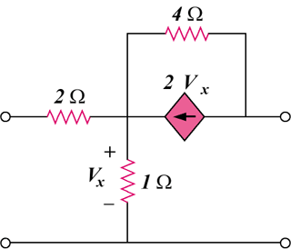

Figure 19.85
For Prob. 19.26.

